

**T.C.**

**İSTANBUL AYDIN ÜNİVERSİTESİ**

**ANADOLU BİL MESLEK YÜKSEK OKULU**

**COMPUTERPROGRAMMING**

**TEST AUTOMATION**

Associate Degree Graduation Project

CANER BASAT

İSTANBUL,2018

**T.C.**

**İSTANBUL AYDIN ÜNİVERSİTESİ**

**ANADOLU BİL MESLEK YÜKSEK OKULU**

**COMPUTER PROGRAMMING**

**MOBILE BASED DRUM GAME**

Associate Degree Graduation Project

CANER BASAT

B1410.033052

Advisor

BAŞAK BULUZ

İSTANBUL,2018

# CONSULTANT SİGNATURE PAGE

# TABLE OF CONTENTS

CONSULTANT SİGNATURE PAGE 3

TABLE OF CONTENTS 4

SUMMARY 5

THANKS 6

PURPOSE 7

BENEFITS 7

WHY MY TEST 7

EXPECTED RESULTS 7

METHODOLOGY 8

WHAT IS SELENIUM 8

WHAT IS ANDROID 8

WHAT IS JUNIT 14

HOW TO TEST 14

SOME PICTURES FROM THE TEST 12

BIBLIOGRAPHY 15

# 

# SUMMARY

HEPSIBURADATEST

CANER BASAT

Computer Programming

Advisor: Head of Department Başak BULUZ

June 2018

Summary

Test automation is a necessary software today. Projects that have been lifted to the foot without being tested have many errors. A test counseling service must be obtained before using these errors. If you do not get it, it will cost you a lot of damage.

KeyWords : Test , autamation , software , errors, cost

# THANKS

I am also thankful for my advisor Başak Buluz and all of my teachers.

# PURPOSE

We will check the correct setting of a korean function. We will let you know when there is a mistake.

# BENEFITS

Faults can be substantial. We will escape from this situation.

# WHY MY AUTOMATION

This service should be avoided from making mistakes, counseling. Otherwise, it increases the cost of finding an error.

# EXPECTED RESULTS

In software, it is inevitable that mistakes can be wrong in various reasons. Applying the consequences of these errors can be damaging to your material or reputation. Software with "Cost, Time, Quality"

Software testing often involves ensuring the quality of the application before submitting it to the customer, Reduce error correction costs, In the first steps, it is necessary to determine the mistakes and prevent the spread of the next steps, To ensure maximum customer satisfaction.

# 

# METHODOLOGY

* JAVA
* Selenium
* Junit
* Assert
* Chrome
* Web driver
* Maven

# WHAT IS SELENIUM

Selenium automates browsers. That's it! What you do with that power is entirely up to you. Primarily, it is for automating web applications for testing purposes, but is certainly not limited to just that. Boring web-based administration tasks can (and should!) be automated as well.

Selenium has the support of some of the largest browser vendors who have taken (or are taking) steps to make Selenium a native part of their browser. It is also the core technology in countless other browser automation tools, APIs and frameworks.

# WHAT IS JUNIT

JUnit is an open source framework designed for the purpose of writing and running tests in the Java programming language. JUnit, originally written by Erich Gamma and Kent Beck, has been important in the evolution of test-driven development, which is part of a larger software design paradigm known as Extreme Programming (XP).

# WHAT IS TEST AUTOMATION

Automated testing is, well, automated. This differs from manual testing where a human being is responsible for single-handedly testing the functionality of the software in the way a user would. Because automated testing is done through an automation tool, less time is needed in exploratory tests and more time is needed in maintaining test scripts while increasing overall test coverage.

# 

# HOW TO TEST

Automation Scripts are executed during this phase. The scripts need input test data before there are set to run. Once executed they provide detailed test reports.

Execution can be performed using the automation tool directly or through the Test Management tool which will invoke the automation tool.

Example: Quality center is the Test Management tool which in turn it will invoke QTP for execution of automation scripts. Scripts can be executed in a single machine or a group of machines. The execution can be done during the night, to save time.

SOME OF THE PICTURES FROM THE HEPSIBURADATEST AUTOMATION

When test started



Login case Codes

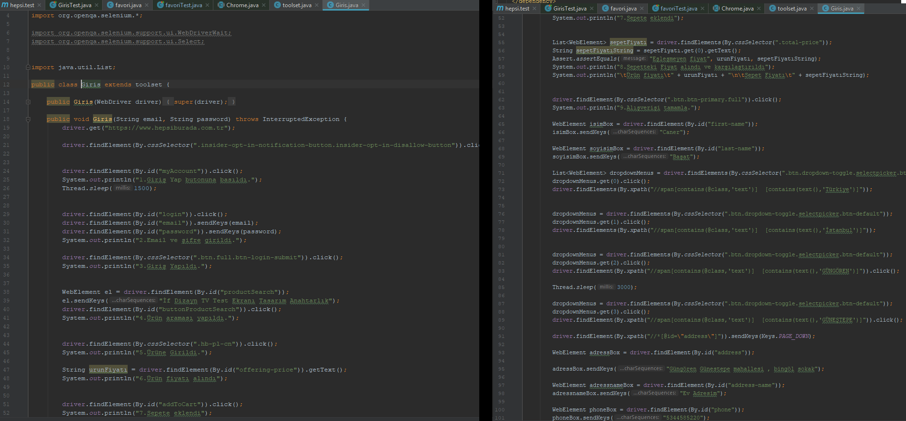

Favori case Codes and logs of test

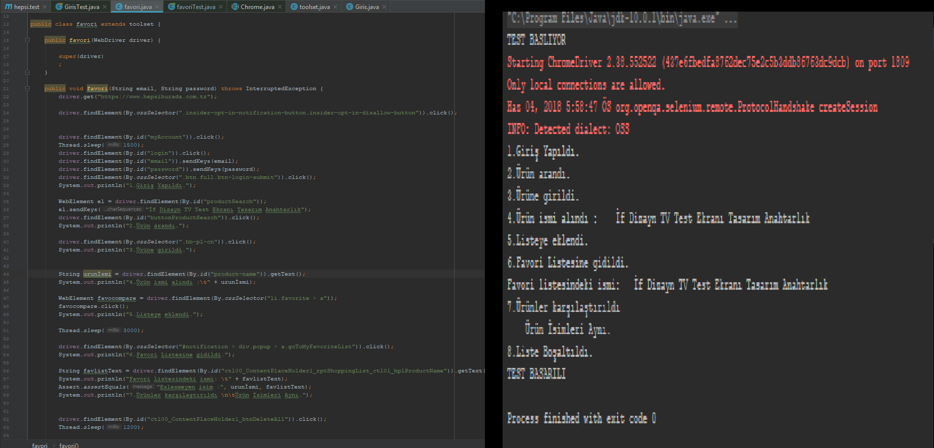

Test Classes

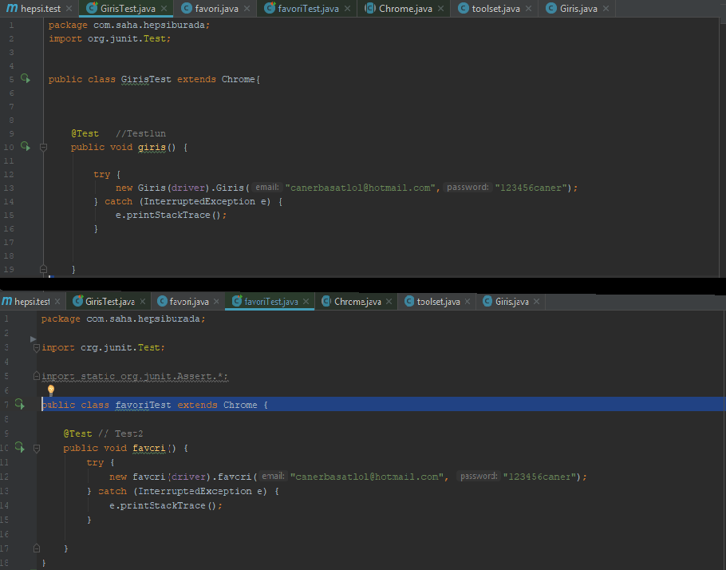

Pom.xml Maven Libraray

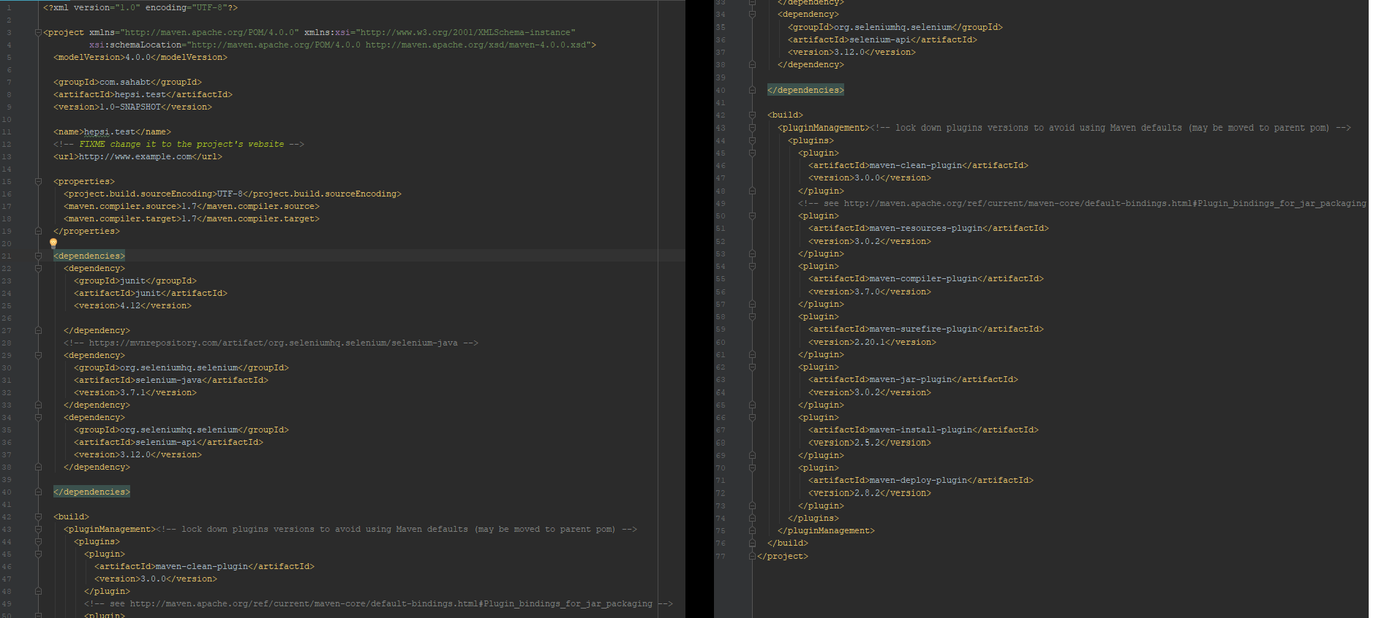

BIBLIOGRAPHY

https://www.seleniumhq.org/

https://searchsoftwarequality.techtarget.com/definition/JUnit

https://mvnrepository.com/

http://www.oracle.com/technetwork/java/javase/downloads/jdk10-downloads-4416644.html

https://blogs.perficient.com/2017/01/11/assertions-in-selenium-web-driver/

https://maven.apache.org/what-is-maven.html

https://www.guru99.com/automation-testing.html